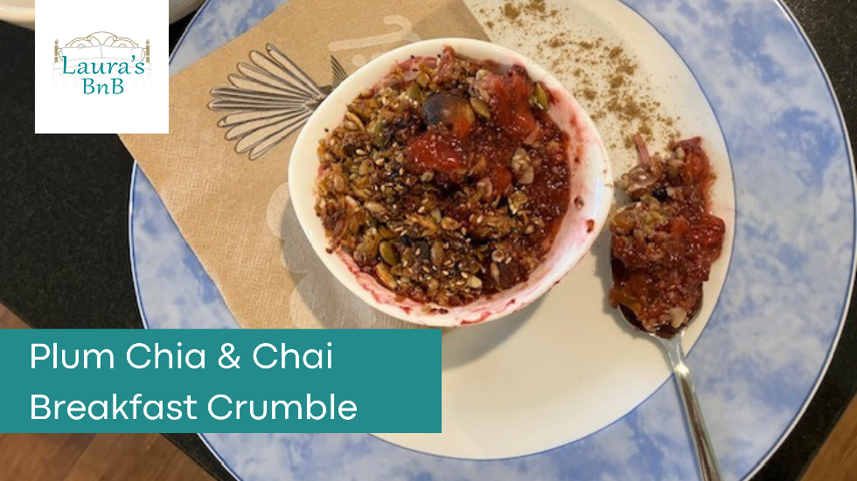

Plum, Chia & Chai Crumble
Makes 3 - 5 servings

Ingredients

Fruit base
1kg (or more) of red flesh plums
1 teaspoon of vanilla liquid stevia (or more to taste)
1 Tablespoon Mons Flavours Chai Masala
¼ cup Black Chia Seeds

Crumble topping
2 heaped tablespoons honey
2 tablespoons butter
1 cup of your favourite untoasted muesli (I make my own with coconut, nuts, seeds & dried fruit)
Pinch of salt

Method
Preheat your oven to 160C.
Take the stone out of all your plums & pop into a large sauce pan with liquid stevia. Just cover with water and set on the stove .
Bring slowly to the boil, stirring occasionally then simmer (lid off) for about 30 minutes to allow fruit to breakdown and reduce.
Allow to cool.
Add Chia seeds & Mons Flavours Chai Masala and stir through.
Allow to sit for the Chia seeds to absorb the liquid.
After an hour or so check thickness of fruit, you should have a think sauce but not jam consistency. Add a little more Chia seeds if not thick enough.
Pour about a cup of fruit for each serving into either individual ramekins or a multiple serving casserole dish. Set aside and make crumble topping.
Add honey and butter to a small clean saucepan with a pinch of salt. Slowly bring to the boil stirring all the time. Allow to bubble up a bit then stir vigorously for about 2 minutes. Take off the heat and add your favourite muesli. Combine well.
Layer crumble topping evenly over fruit mixture and bake in the oven for about 30 minutes. Serve with unsweetened Greek yoghurt and a sprinkling of Mons Flavours Chai Masala on top for the aromatics.

Laura’s BnB - Pyes Pa, Tauranga
+64 27 477 7701 - http://laurasbnb.co.nz - info@laurasbnb.co.nz

