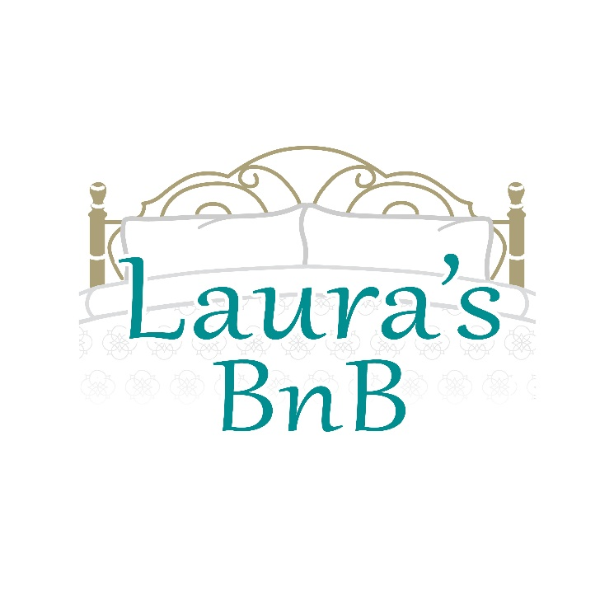
Chickpea Flatbread
1 ½ cups chickpea flour
2 cups warm water
3 teaspoons rock or mineral salt (I use Masterfoods Herb & Garlic salt)
3 teaspoon dried herbs (Italian herbs)
olive oil (small splash in the batter)
Whisk together all ingredients.
Leave to stand for about 30 minutes. Mixture may thicken up as the chickpea flour absorbs the water.
Preheat oven to 250 C
On your stove top heat a thin layer of olive oil covering the bottom of the pan. A non stick works best.
Pour the batter into the pan once a whisp of smoke comes up from the oil.
Pop the pan into the hot oven for 30 minutes.
Cut bread and serve.

es or sundried tomatoes – You can use almost anything).. 
Laura’s BnB - http://laurasbnb.co.nz
61 Contour Avenue, Pyes Pa, Tauranga

