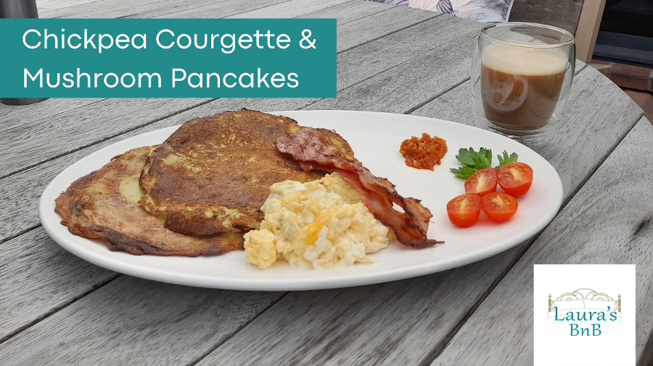

Chickpea Courgette & Mushroom Pancakes
Makes 8 pancakes

Ingredients
2 cups chickpea flour
2 cups lukewarm water
3 teaspoons rock or mineral salt
3 teaspoon Italian herbs
2 grated Courgettes (Zucchini)
6 sliced Mushrooms
Olive Oil (small splash in the batter)

Method
Whisk together flour and water. Add herbs, oil and salt. Whisk through.
Add courgettes & mushrooms. Mix together.
Leave to stand for about 30 minutes. Mixture may thicken up as the chickpea flour absorbs the water.
Heat olive oil in a non stick pan.
Pour some batter into the pan and shake to cover the bottom of the pan. Cook until golden then turn over and cook the other side.
Serve hot.

Optional extras
Makes a delicious breakfast when served with eggs, bacon and some Sundried tomato, redd pepper and cashew nut pesto.

Laura’s BnB - Pyes Pa, Tauranga
+64 27 477 7701 - http://laurasbnb.co.nz - info@laurasbnb.co.nz

