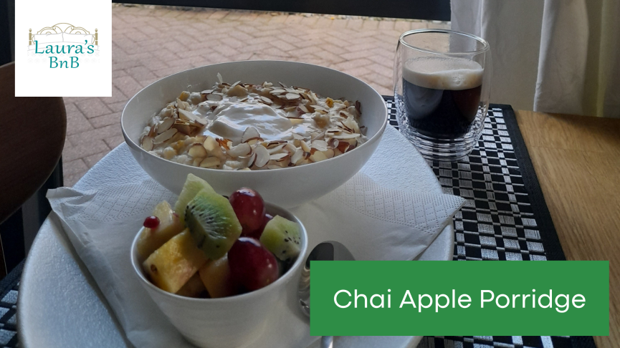

Chai Apple Porridge
2 large or 3 medium servings

Ingredients
1 cup organic oats
1 cup diced fresh apple skin on (stewed apple or apple sauce OK too)
½ cup ground almonds
1 heaped teaspoon Mon’s Flavours Chai Masala (or more if you like more spice)
½ teaspoon French vanilla stevia liquid (or other sweetener of your choice)
½ cup walnut pieces or slivered almonds (optional)

For the topping
Mon’s Chai Honey
Greek yoghurt

Method
Pop all the ingredients into a saucepan or bowl.
Add enough milk of your choice (I like coconut milk) mix to make a slurry.
Leave overnight in the fridge or kitchen bench.
The oats will absorb the wet ingredients and the flavour will develop overnight.

In the morning…
Add more milk or water and cook porridge until desired thickness and serve with Greek yoghurt and a spoonful of Mon’s Chai Honey on top.

Contact us
Laura’s BnB - Pyes Pa, Tauranga
+64 27 477 7701 - http://laurasbnb.co.nz - info@laurasbnb.co.nz

